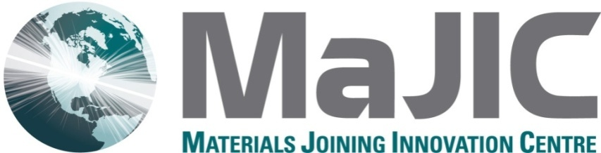

P.O. Box 303, Kirkland Lake, Ontario P2N 3H7
info@majic-ca.org
Phone / téléphone: (705) 567-6411
Fax / télécopie: (705) 567-6303

Help Support MaJIC!

I pledge a donation to the Materials Joining Innovation Centre (MaJIC) of:

□ $100. □ $250. □ $500. □ $1000. □ Other:
□ One time only □ In each of 2011, 2012 and 2013 □ Other:
□ I am a graduate of Northern’s School of Welding Engineering Technology
Year:

If you wish to receive a tax-deductible receipt, please make cheques payable to The Northern College Foundation - MaJIC. If no tax receipt is required, please make your cheque payable to MaJIC.

Please send tax-deductible receipt to:
Name:
Mailing Address:

E-mail:
Phone/Fax:

Send your cheque to MaJIC, PO Box 303, Kirkland Lake, ON P2N 3H7.

Please donate today and help support MaJIC!

